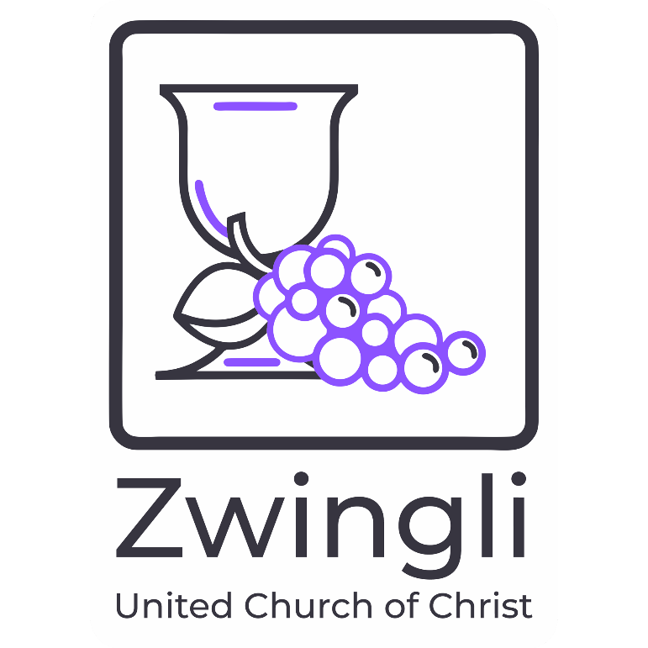

SEPTEMBER
2026

ZWINGLI HILL NEWS
SEPTEMBER 2026
Volume 64 No. #7

Table of Contents

A Note from Our Pastor 3
Ministry of Educators 4
Zwingli Summer Sunday Socials 9
Ministry of Missioners 10
Ministry of Stewards 12
Healthy Moment 14
Swag Store 16
Volunteers 21
Zwingli Staff 23
September Birthdays 24

Dear Zwingli Members and Friends,

What's Ahead This Fall

There's a familiar rhythm to this time of year — backpacks by the door, school bells ringing, and our church family settling back into the pace of fall. It's a season of return: to routine, to community, and to one another. We're so glad you're walking into it with us.
Our committees, which took a well-earned rest over the summer, are back in session starting in September. If you serve on a committee, keep an eye out for updated meeting schedules from your chair — and if you've been thinking about joining one, this is a great time to jump in. Bible Study also returns this month, offering a steady, welcoming space to dig into scripture together, ask questions, and grow in faith side by side. Whether you've been with us every week or it's been a while, there's a seat waiting for you.

Then, beginning September 13, we're excited to launch something new: our Community Conversations series — a season of honest dialogue, deep listening, and spiritual formation centered on Cultural Competency/Humility, Radical Inclusion, and Anti-Racism. This is sacred, sometimes challenging work, and we believe it's exactly the kind of work our faith calls us to. Head to the Christian Education section below for the full lineup of books and how to get involved.

And just two days later, on September 15, we step into Hispanic American Heritage Month — a joyful season to not only acknowledge but truly celebrate our Hispanic American siblings, their rich histories, varied ethnicities, cultures, and the countless ways they enrich the body of Christ and our local communities. Watch for more details soon on how we'll mark the season together — through worship, fellowship, and celebration.

Lean into curiosity and learn more at:

https://latino.si.edu/learn/teaching-and-learning-resources/hispanic-heritage-month-resources

Fall is full this year — full of return, full of learning, full of celebration. We can't wait to move through it together.

Rev. Joslin

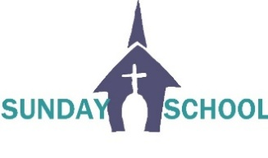

Ministry of Educators: Fall Kickoff

Rally Day is Coming Sunday, September 13
Join us as we kick off a new year of faith, learning, and fellowship!
- Sunday School begins for children ages 3 through 5th grade
- Youth Group will also be meeting
- Adult Elective Classes begin, offering opportunities for learning, discussion, and spiritual growth
Families, make Rally Day a priority! Bring your children, invite a friend, and come discover all the opportunities available for every age. There's a place for everyone as we grow together in faith and community. 🌟🙏

Adult Electives — Fall Schedule
Our Adult Elective hour offers a rotating lineup of learning opportunities. Check out these highlights for this fall:
Date | Class | Leader
Sept 13 | Community Conversations  Session 1 – Info & Intro Lesson | Rev. Joslin Kearse
Sept 20 | Community Conversations - Session 2 | Rev. Joslin Kearse
Sept 27 | The Legacy of Dr. Frank Boston | Pat Rieker, President  Lansdale Historical Society
Oct 4 | Adult Bible Study — Joshua & Judges | Jonathan Widgins
Oct 11 | Community Conversations  How to Have Difficult Conversations | Rev. Joslin Kearse
Community Conversations: Cultural Competency, Radical Inclusion & Anti-Racism Beginning September 13 at 10:30am, this facilitated series explores Cultural Competency, Radical Inclusion, and Anti-Racism through guided discussion, reflection, and shared learning. Together we'll journey through three transformative books:
- Where the Edge Gathers: Building a Community of Radical Inclusion by Yvette A. Flunder — available here
- The Racial Healing Handbook: Practical Activities to Help You Challenge Privilege, Confront Systemic Racism, and Engage in Collective Healing by Anneliese A. Singh, PhD — available here
- Autopsy of a Deceased Church: 12 Ways to Keep Yours Alive by Thom S. Rainer — available here
This series is an invitation to grow together in courage, compassion, and truth-telling — as individuals and as a community of faith. Whether you're new to these conversations or have been doing this work for years, there's a seat for you at the table. The first session on September 13 will be an information session that includes an introductory lesson.
The Legacy of Dr. Frank Boston (Sept 27, in the parlor) Learn about the man who established the Volunteer Medical Service Corps (VMSC), one of the earliest ambulance corps in the country, helping lay the groundwork for modern emergency medical service. He also founded a hospital in Lansdale so members of the community could receive care at a time when access was limited — a hospital that would later become part of what is now Jefferson Lansdale Hospital.
Adult Bible Study — Joshua & Judges (Oct 4, in the parlor) Drawing from the Standard Lesson Commentary series, we'll explore a people finally settling into the Promised Land under Joshua's prayerful command, followed by a time when every settled tribe in Israel relied on the often sporadic leadership of Judges, each with differing gifts of dynamic insight. All are welcome.

Volunteers Needed!
Sunday School teachers and helpers are needed. Please look for the sign-up sheet and add your name if you're interested. Required clearances must be completed prior to volunteering.

LYFT: Linking Young Families Together
Beginning in October, LYFT will meet on the first Sunday of each month. While children enjoy Sunday School, parents and caregivers are invited to gather for food, fellowship, and encouragement — meaningful conversation, building supportive relationships, planning group activities for the year, and a little time to relax and connect.
We look forward to seeing you there!

🎃 WE NEED YOUR HELP FOR TRUNK OR TREAT! 🎃
Hi friends!
Our Trunk or Treat is happening on Saturday, October 24 at 3:00 PM, and we need a few more helping hands to make it a spook-tacular afternoon of fun!
We're looking for:
🚗 Decorated trunks to hand out candy- the more Trunks, the better. Ask a friend to decorate a Trunk!
🙋 Volunteers to help with games, setup, and cleanup
🍪 Food and treat donations
🎃 Pumpkins, and candy
👥 Friends and family. Bring someone along!
No tricks, just treats. We'd be gourd-geous if you'd sign up to help! 🎃😉
Whether you can decorate a trunk, donate supplies, volunteer for a little while, or simply invite a friend, every bit of help makes a difference. If you have any other suggestions to make this a spook-tacular day, please contact the Educators. (Erin, Marissa, Gabriella, Ed or Pastor Alan)
Look for sign ups soon!
Thanks for helping us create a fun and welcoming event for everyone. We can't wait to celebrate with you!
🍂 Food • Fun • Pumpkins • Games • Candy 🍂



THE CIRCLE OF SISTERS BOOK CLUB!
7PM in the Bright Space Room

September 24, 2026 at 7pm

The Correspondent by Virgina Evans – Host: Marian Eide
A gripping, easy-to-follow mystery perfect for book club readers. The Correspondent follows a young journalist whose routine assignment turns into a high-stakes investigation. As unexpected clues surface, the reporter is pulled deeper into a web of secrets that challenges their instincts, integrity, and courage. Fast-paced and accessible, this story blends suspense with themes of truth-seeking and personal responsibility — an engaging pick for readers who enjoy a smart, compact thriller.

October 28, 2026 at 7pm
The Things We Never Say by Elizabeth Strout – Host: TBD
A tender, quietly powerful story about the truths we hold close and the emotions we struggle to voice. The Things We Never Say explores the unspoken tensions, regrets, and connections that shape a family’s life, revealing how silence can both protect and wound. With Strout’s signature warmth and insight, this short work offers a moving reflection on love, honesty, and the complicated bonds that define us.

ZWINGLI SUMMER SUNDAY SOCIAL

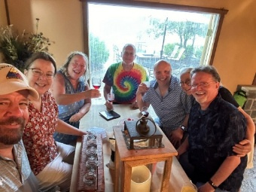
Our Final Zwingli Summer Sunday Social for 2026!
Come and enjoy good conversation, live music, tasty wine/beer, and the great outdoors! Bring a snack to share. Seating is provided. No need to sign up, just show up. This event is open to all ages.
Cost: Whatever you choose to buy. There is no cover charge.
September 6 from 1 - 4pm @ Adello’s Winery, 21 Simmons Rd, Perkiomenville, PA 18074. http://adellowines.com/
See Lisa Cinciripini with questions.

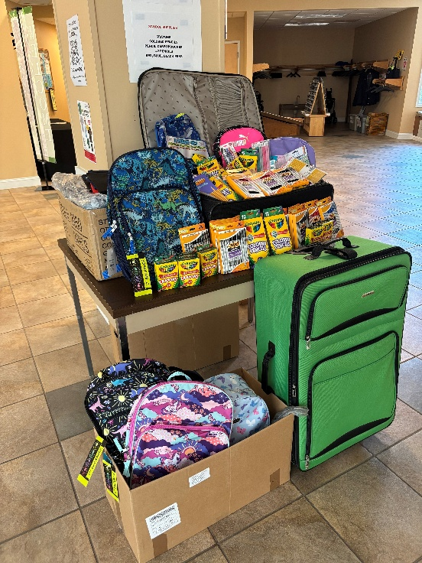

HANDS AND HEARTS COLLECTION

Thank you for your generosity in supplying backpacks and school supplies for children in the Hands and Hearts for Jesus Summer Mission/Youth project. These supplies will be taken to Costa Rica by Hands and Hearts missionaries in time for the start of school in January. The money collected by the youth will be used to pay for baggage costs. Any remaining money will be used by the school to buy supplies that are too heavy to ship.



The Neighbors in Need (NIN) offering is one of the Special Mission Offerings of the United Church of Christ. NIN supports ministries of justice and compassion, with one-third of the offering given to the Council for American Indian Ministries and the remaining two-thirds supporting UCC justice ministries. Envelopes are in the chair racks. We will be collecting for the NIN ministry until October 4.

THANKSGIVING FOOD BAGS

The Missioners will be collecting food again this year for distribution to needy families in our community through Keystone Opportunity Center. However, KOC is planning a new program for this year. Details aren’t finalized yet, but mid-November will be the deadline instead of the end of October. More details will be outlined in the October newsletter

CEMETERY PLOTS - WHITEMARSH MEMORIAL PARK

Due to generous members donations, Zwingli has nine grave sites at Whitemarsh Memorial Park. We are offering those grave sites for a donation $1,000 each, plus a $395 transfer fee. The transfer fee can be waived if you are purchasing other products and services at the time of signing. Two of these include vaults. After our members are given priority, we will then advertise outside our church, followed by letting local funeral homes know about the availability. Contact Ed Bibic or the church office for more information.

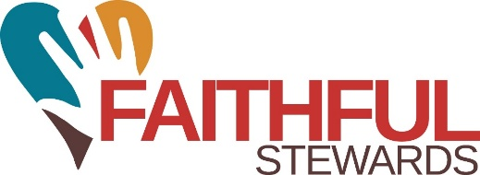

MINISTRY OF STEWARDS – AUGUST 2026

While stewardship graphics are not available at this time, we do know that our general fund is now at ($6,992.01) with expenses vs income. We are at full staff and also in a time of vacations for many of our members which can affect our weekly giving. Slow periods like this are yet one more reason why the Stewards consistently talk about giving electronically.

A FAQ information page is part of this mailing and we strongly encourage all members to give electronically. If we have missed a question that you have, please be in touch with one of the Stewards…Jess Jalboot, Lois Johnston, Bradd Klausfelder or Sue Wack. Even though you may not be in the chairs, your giving continues to support our budget and our outreach beyond our walls. There are also other ways to give including scanning the QR code below. In addition, donations may be given through the offering plate as well as our website by clicking the donate button or mailing or dropping off your contribution at the church office. We accept your donations in whatever way is most comfortable for you. Thank you for your continuing support of the ministry of Zwingli Church of Christ.



ELECTRONIC GIVING AT ZWINGLI - FREQUENTLY ASKED QUESTIONS

Electronic giving allows you to make donations online or automatically through a bank account, debit card, or credit card without needing cash or checks.

Why does the church offer electronic giving?
Electronic giving provides a secure, convenient, and consistent way to support the church’s ministries and operations throughout the year.

What types of electronic donations are accepted?

You can donate securely at https://zwingli.org/donate. Or you can update your EFT information by downloading the EFT form here.

Is electronic giving secure?
Yes. Donations are processed through secure, encrypted payment systems that meet industry security standards.

Can I still give by check or cash?

Absolutely. Electronic giving is optional and simply provides another convenient giving method.



Healthy Moment
Understanding Dementia
By Kristie Lowery, Faith Community Nurse

“³Praise be to the God and Father of our LORD Jesus Christ, the Father of compassion and the God of all comfort, ⁴who comforts us in all our troubles, so that we can comfort those in any trouble with the comfort we ourselves receive from God “ 2 Corinthians 1:3-4
Dementia is not a single disease, it’s an overall term to describe a collection of symptoms that a person may experience if they are living with a variety of diseases, including Alzheimer’s disease. Diseases grouped under the general term “dementia” are caused by abnormal brain changes. Dementia symptoms are associated with a decline in thinking skills, also known as cognitive abilities, severe enough to impair daily life and independent function. The diseases that cause dementia also affect behavior, feelings, and relationships. Types of dementia include Alzheimer’s, Vascular, Lewy Body, and Frontotemporal.
Dementia is caused by a variety of diseases that cause damage to brain cells or the structures surrounding the brain cells This damage interferes with the ability of brain cells to communicate with each other. When brain cells cannot communicate normally, thinking, behavior and feelings can be affected. The brain has many distinct regions, each of which is responsible for different functions (memory judgement and movement).
An early stage of memory loss or other cognitive ability loss is called mild cognitive impairment (MCI) which can progress to dementia and can vary greatly. Examples include problems with :
- Short term memory
- Keeping track of a purse or wallet
- Paying bills
- Planning and preparing meals
- Remembering appointments
- Traveling out of the neighborhood (easily disoriented)
Dementia is progressive, which means that the signs of cognitive impairment start out slowly and gradually get worse over time. If you or someone you know is experiencing memory difficulties or other changes in thinking skills, do not ignore them. See a doctor to determine the cause. An early diagnosis can improve a person’s options for treatment: quality of care and quality of life. It can also help to reduce the financial and emotional impact of the disease.
There is hope for people experiencing early-stage dementia. The U.S. Food and Drug Administration has approved treatments that could change the course of the disease for some people living with the early stages. If a loved one is experiencing memory changes, you are encouraged to meet with your health care provider for a thorough evaluation and diagnosis. If you know of someone that has been diagnosed with Alzheimer’s or another type of dementia, consider contacting The Alzheimer’s Association. They can provide resources, information, education, referral and support. You can contact them as listed below:
Free 24/7 Helpline: 800-272-3900
Information for Alzheimer’s and dementia caregivers: alz.org/care
Locate a support group: alz.org

References:
National Alzheimer Association. Httpsw://alz.org
Article adapted from patient pamphlet from The Alzheimer’s Association titled “Understanding Dementia – What it is, how it appears and where you can get help.”

SWAG STORE

The Zwingli Swag Store is LIVE!

Items available for purchase are T-shirts, hoodies, sweatshirts, hats, baby items, stuffed animal friends, water bottles, mugs, stickers, buttons, bandanas for you or your pet, and so much more!!!
Pay online and have items shipped directly to your house, visit zwingli-ucc-souderton.myspreadshop.com or scan the QR code and buy your swag today!

Not comfortable with going online to order? See Jason Burns at one of the tables after service with your debit or credit card, and he will assist you in showing off your Zwingli pride!

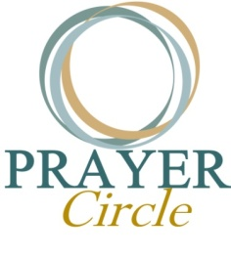

WEDNESDAY PRAYER CIRCLE

If you want to be part of the Prayer Circle, please let the church office know, and we will send you the link. We will meet for Prayer Circle with Pastor Butch and Pastor Alan each Wednesday of the month from 12:00 to 12:30. We feel that heartfelt communal prayer is especially needed consistently as we continue to deal with individual, family, and church concerns, as well as other societal issues and direction.

DO YOU HAVE A PRAYER REQUEST?

We want you to know that you are not alone, and we would be honored to pray with and for you. To make sharing prayer requests easier, we now have a dedicated email address:

prayer@zwingli.org

Messages sent to this address will go directly to the pastors.

When you send your request, please let us know if you would like it to be shared and prayed for during Sunday worship, added to the prayer chain, or kept private and confidential.

Thank you for using this email address so that both pastors can stay connected to your prayer needs and walk alongside you in prayer.

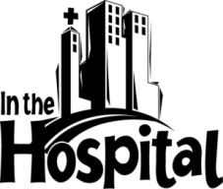
WE’RE HERE FOR YOU – KEEP US IN THE LOOP

If you are a loved one is admitted to a hospital, rehabilitation center, or any healthcare facility, we kindly ask that you reach out directly to the church office or one of our pastors. Let us know if you’d welcome a pastoral visit or prayer support. We deeply value the opportunity to walk alongside you during times of healing and uncertainty. Calling the church office is the surest way for us to stay connected and offer the care and comfort your deserve.



STAY INFORMED

If you want to stay current on what Zwingli Ministries and Council are doing, pick up a Pre-Council Report from the vestibule or contact Lisa in the office for an electronic copy. See the engaging ideas that your leaders are sharing!



INK TONER CARTRIDGES COLLECTION - ON HOLD

Thank you for all the donations of ink cartridges over the years. We have so many now that the collection has been put on hold. Once we recycle them all, we’ll start the collection back up again. Thank you!


SIMPLE WAYS TO HELP THE
GENERAL FUND BUDGET

Purchase a grocery store gift card from Zwingli Church, and 5% of your purchase goes to Zwingli’s General Fund. On Sunday mornings or through the church office during the week, you can purchase a $25, $50, or $100 gift card to Giant Stores or Landis Supermarket for grocery shopping. This fundraiser supports the ministry of Zwingli UCC.

Thank you for participating in this program!

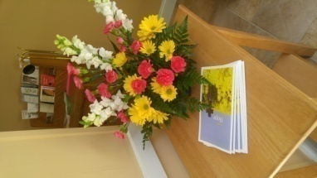

2026 FLOWER, BULLETIN AND POSTAGE SPONSORSHIPS

Would you like to sponsor the flowers on the chancel one Sunday morning or the printing of the bulletin or help us with our card ministry?

Chancel flowers are $50.
Bulletins are $15.
Postage Donation of $30 or drop off a sheet of first-class stamps
Please pick up a form from the bulletin board next to the office to sponsor the above. Once completed, attach a check and drop it off in the office. You can also mail it in or place it in the offering plate. Our mailing address is 350 Wile Avenue, Souderton, PA 18964. We appreciate your support.

SUNDAY MORNING USHERS/GREETERS
September 6 Maureen Hartman, Liz Bibic
Tom and Toni Kramlik
September 13 Susie and Dale Woodland
Jim See
September 20 Marissa Tice family
Kristie Lowery, Mark Comden
September 27 Jen Smeed, Miles Smeed
Pam and Pete Myers
October 4 Lisa Cinciripini
Laurie and John Reynolds
October 11 Charlotte Kramer, Carol Wenger
Rick and Missy Rogers
REFRESHMENTS
September 6 Bonnie Algeo, Susie Hayden
September 13 Diane Chinault, Sue Ludwig
September 20 Donna Henry, Nancy Hafler
September 27 Ministry of Educators
October 4 Susie Woodland, Charlotte Kramer
October 11 Sue Pro, Sandy Schuler
ACOLYTE
September 6 Alex Vogt
September 13 Adrien Tice
September 20 Callie Leake
September 27 Caleb Jalboot
October 4 Harrison Neff
October 11 Evan Chalmers
GIFT CARD SALES
September 6 Maureen Harstman
September 13 Pam Myers
September 20 Carol Wenger
September 27 Betsy Villareal
October 4 Lisa Cinciripini
October 11 Maureen Hartman

MONEY COUNTERS
September 6 Charlotte Kramer, Erin Chalmers
September 13 Sue Wack, Marian Eide
September 20 Bradd Klausfelder, Joanne Kramlik
September 27 Lee and Lois Hunsicker
October 4 Ed and Liz Bibic
October 11 Kristie Lowery, Becky Klausfelder
NURSERY COVERAGE
September 13 Laurie Reynolds, Kathy Pendleton
September 20 Beth Algeo, Julie Neff
September 27 Jen Smeed, Kristie Lowery
October 4 Sue Rauch, Monica Jalboot
October 11 Marissa Tice, Pam Myers
TRUSTEE ON DUTY
September 6 Butch Hafler
September 13 Rich Hartman
September 20 Miles Smeed
September 27 Tom Cinciripini
October 4 TBD
October 11 TBD
FACEBOOK
September 6 Kristie Lowery
September 13 Flo Rutherford
September 20 Sue Wack
September 27 Erin Chalmers
October 4 Dale Woodland
October 11 Lisa Cinciripini
SOUND SYSTEM
September 6 Miles Smeed
September 13 Sue Wack
September 20 Mark Comden
September 27 TBD
October 4 Rick Rogers
October 11 TBD

*PLEASE NOTE: If you cannot participate on your scheduled Sunday, please call one of the other individuals on the list and arrange to switch dates.

******************************************************
DEADLINE FOR SUBMITTING MAILING
ARTICLES FOR THE OCTOBER 2026 MAILING IS
MONDAY, SEPTEMBER 14, 2026 !
******************************************************

Zwingli UCC Staff
Joslin Love Kearse, MBA, MDiv, MAST, CSSC…………..Interim Pastor
Alan Miles, M.Div…................................................ Associate Pastor
Steve Emery……………………………….…..….Director of Music/Organist
Lisa Cinciripini…………………………..……………..… Office Administrator
Kristie Lowery……………………………………………….……...Office Assistant
Zwingli United Church of Christ, 350 Wile Avenue, Souderton, PA
Phone: 215-723-1186 Fax: 215-723-5402
www.zwingli.org office@zwingli.org
Office Hours
M- TH: 8:30-4:30, F: 8:30-3:30 Closed Daily 12-1
Some images in this publication are used with permission from Bogdan Rosu, Freepik, and High-Quality Icons.





